Professor Francis Keenan

Professor of Astrophysics and former Head of School of Mathematics and Physics
I have suffered from a number of eyesight issues for several years, and support from the Equality and Diversity Unit within Queen’s has been of enormous benefit.
First of all, the Unit has very generously paid for frequent, detailed eye tests, to allow my condition to be regularly monitored so that any new issues with my eyesight can be immediately addressed. On a few occasions I have also needed additional eye tests at short notice to address specific concerns with my eyesight, and the Unit has supported these.
Staff both in the Unit and in my School have in addition provided expert advice and support in arranging my office to minimise the effects of my eyesight issues. These include the use of low-level uplighting rather than the normal bright overhead lights, changes to my computer display to reduce glare, and the provision of a personal printer to minimise the time I need to spend reading documents on a computer screen. All of these have greatly reduced the impact of my eyesight issues on my day-to-day work activities.
The support I have received from the Equality and Diversity Unit and the School over the years has been truly outstanding, both in terms of helping to address my eyesight issues and providing reassurance that any problems I encounter will hopefully be quickly identified and addressed.
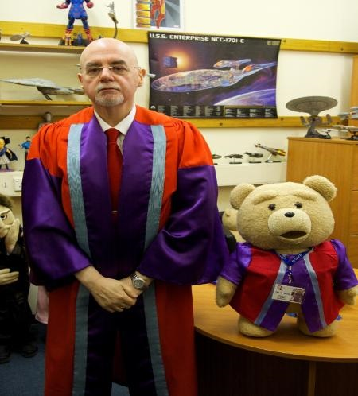

Professor Francis Keenan, together with Ted of School of Mathematics and Physics. Prof Keenan is on the left of the picture.

