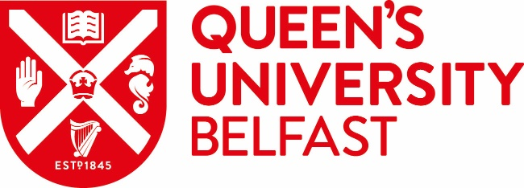 |  | INSERT PARTNER LOGO/CREST

MEMORANDUM OF UNDERSTANDING

Between

The Queen’s University of Belfast
Belfast
BT7 1NN
Northern Ireland

And

XXX University

Date:

Memorandum of Understanding

1. This Memorandum of Understanding (MOU) was made on the ______day of ____________ 202_

Between: The Queen’s University of Belfast (hereinafter called Queen’s) and the XXX University (hereinafter called XXX).

2. The purpose of this MOU is to promote co-operation between Queen’s and XXX. The two institutions agree as follows:-

2.1 Each institution will encourage contact and co-operation between their faculty/school and administrative staff, departments and research institutes.

2.2 Within fields that are mutually acceptable, the following general forms of cooperation will be pursued:-

- Visits by and exchange of graduate students for study and research
- Visits by and interchange of staff for research, teaching and discussions
- Exchange of information
- Joint research activities

2.3. Each party understands that any subsequent financial arrangements will have to be negotiated on an activity by activity basis and will depend on the availability of funds. Specific details for the implementation of these activities will be developed mutually for specific projects. This MOU will have, from time to time, annexes attached to it with regard to these specific projects and any financial arrangements negotiated.

2.4. If the MOU remains dormant for three consecutive years it will be deemed to have lapsed. Where the MOU continues to be active, the two institutions agree to review it after five years from the date hereof. A party may terminate it at any time by mutual consent or by six months’ notice in writing to the other parties.

3. This MOU may be executed in any number of counterparts, each of which when executed and delivered shall constitute an original of this Agreement, but all the counterparts shall together constitute the same agreement.

SIGNATORIES

Signed on behalf of The Queen’s University of Belfast

__________________ _______________
Pro- Vice-Chancellor Date

Signed on behalf of the XXX University

__________________ _______________
Position Date

Last updated 22 August 2022

