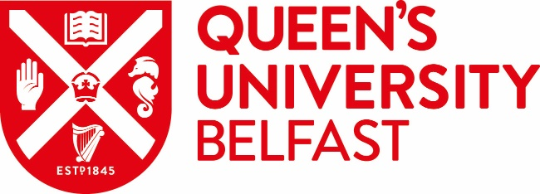 |  | ADD PARTNER LOGO

MEMORANDUM OF UNDERSTANDING

Between

The Queen’s University of Belfast
Belfast
BT7 1NN
Northern Ireland

And

XXX University

Date:

Memorandum of Understanding

1. This Memorandum of Understanding (MOU) was made on the ______day of ____________ 202_

Between: The Queen’s University of Belfast (hereinafter called Queen’s) and the XXX University (hereinafter called XXX).

2. The purpose of this MOU is to promote co-operation between Queen’s and XXX. The two institutions agree as follows:-

2.1 Each institution will encourage contact and co-operation between their faculty/school and administrative staff, departments and research institutes.

2.2 Within fields that are mutually acceptable, the following general forms of cooperation will be pursued:-

- Visits by and exchange of graduate students for study and research
- Visits by and interchange of staff for research, teaching and discussions
- Exchange of information
- Joint research activities

2.3. Each party understands that any subsequent financial arrangements will have to be negotiated on an activity-by-activity basis and will depend on the availability of funds. Specific details for the implementation of these activities (each a “Project”) will be developed mutually for each specific project, following the official guidance and advices linked to international education and/or research. This MOU may be amended but for the avoidance of doubt, each Project will be subject to agreement of appropriate legally binding terms and conditions, which shall form separate contractual agreements.

2.4. This MOU is not legally binding on either party. For the avoidance of doubt, each party further reserves the right to restrict or cease any activities as they may deem necessary to meet their legal or ethical obligations, or as required by their internal policies, including areas relating to the development of, or access to, sensitive technologies or those with the potential to impact national security. Higher risk research activities will be subject to additional due diligence under section 2.3.

2.5 If the MOU remains dormant for three (3) consecutive years it will be deemed to have lapsed. Where the MOU continues to be active, the parties agree to review it after five (5) years from the date of execution hereof. This MOU may be terminated without notice at any time (a) by mutual consent; or (b) if either party should deem it necessary to terminate the MOU to comply with applicable legal, regulatory or policy requirements, including requirements relating to export control or national security. The MOU may also be terminated by either party providing six (6) months’ notice in writing to the other party.

3. This MOU may be executed in any number of counterparts, each of which when executed and delivered shall constitute an original of this Agreement, but all the counterparts shall together constitute the same agreement.

SIGNATORIES

Signed on behalf of The Queen’s University of Belfast

__________________ _______________
Pro- Vice-Chancellor Date

Signed on behalf of the XXX University

__________________ _______________
Position Date

Version Approved: 15 August 2024

