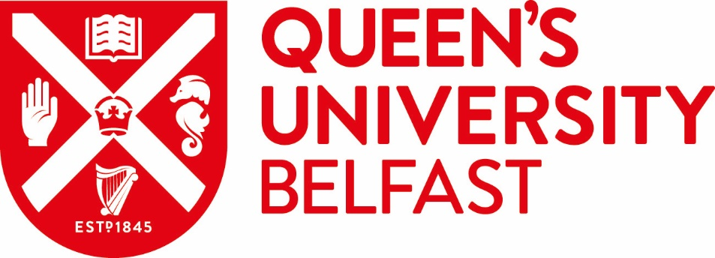
Global Student Ambassador Programme
Code of Conduct

Queen’s University Belfast Global Student Ambassadors are representatives of the University and are expected to abide by a code of conduct.

Global Student Ambassadors should:
- Attend appropriate training.

- Promote Queen’s University Belfast at all times.

- All information given about the University, Further and Higher Education should be accurate and provided in a positive way to all.

- Ensure that any advice, information or opinion provided on behalf of the University is correct and up to date.

- Have a proactive attitude and show willingness and enthusiasm in undertaking the variety of tasks requested.

- Forward any prospective student enquiries to the appropriate members of staff, for example, Faculty Hub staff, Global Student Recruitment team, etc.

- International student ambassadors will keep a record of work to ensure they don’t work more hours than what is outlined on their student visa.

- Allow their contact details to be shared on an individual basis with other members of the Queen’s community (including staff, alumni, prospective and current students).

- Acknowledge and respect other ambassadors and their contributions, treating them equally as peers.

- Treat confidential matters and materials with the highest degree of integrity.

- Adhere to all health and safety policies and procedures.

- Ensure professionalism at all times.

- Dress appropriately.

- Be punctual for duties.

- Declare any conflict of interest that may have a negative reputational impact on Queen’s at the earliest opportunity.

Global Student Ambassadors should not:
- Host any University events without approval from Queen’s.

- Use social media, email or any other communications to do anything unlawful, misleading, malicious, or discriminatory; or fail to report any posts or communications that falls into this category.

- Make any promises or guarantees to prospective students (unless consistent with the standard literature).

- Bring Queen’s, its staff, students, or programmes into disrepute.

All members of the Global Student Ambassador Programme, while engaged in any official capacity related to Queen’s, are expected to uphold the highest standard of ethical behaviour and personal conduct at all times. They are responsible for promoting Queen’s positively and for conducting themselves in such a way as demonstrates professionalism at all times.

