
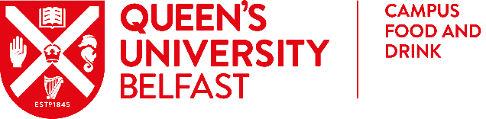

Christmas Menu

Smoked salmon & prawn cocktail
Pink grapefruit & paprika dressing
Or
Carrot, lentil & coriander soup
Roasted focaccia crumb

Traditional roast turkey & baked ham
Lemon, chestnut and cranberry stuffing, calvados thyme jus
Or
Braised daube of beef
Roast Portobello mushroom and shallot, merlot red wine jus
Or
Roast red pepper, asparagus & edamame bean risotto (VE, GF)
Beetroot and vegan Applewood cheese topping
Tomato & coriander sauce

Served with chef’s seasonal potatoes & vegetables

Great Hall Christmas pudding
Mascarpone cream with basil praline, brandy anglaise
Or
Belgium chocolate mousse torte
Coffee cream, mixed fruit compote

Fairtrade coffee, tea & dinner mints

Lunch £ 35
2024

