1. Set up a Zoom account and store log in details.
Email address for this account
Password

2. No Zoom software on the computer you have available?
https://zoom.us/ this takes 2 minutes (add this link to favourites for future access)

3. Need to start a new meeting for whatever reason
Arrange in advance for students to log in again using same meeting link if meeting ends unintentionally (eg time runs out) OR start a new meeting quickly as below and share link by new email
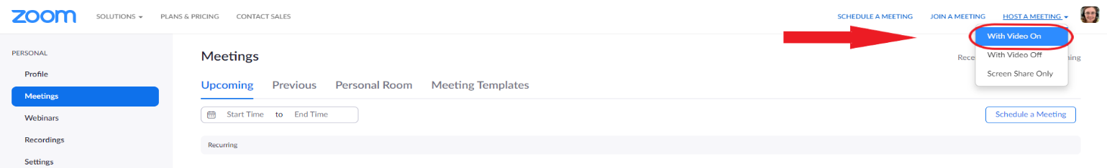
Once in the meeting, invite the students back by copying the meeting-invite link and emailing the group
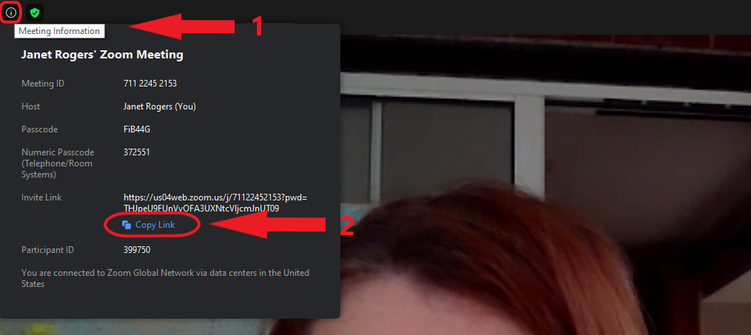

Student Name | Email address | Mobile number
 |  | Share number for 1 student

4. Poor audio quality
Ask all participants to mute; only 1-2 unmute at a time as required; increase use of chat instead.
Encourage use of headphones / microphones if available
Can those affected use a PC / laptop rather than a phone?
Move out of range of other devices if there’s interference; someone may have joined on both phone and PC

5. Poor internet connection
Ask participants to turn off video to reduce data-demanding visual sharing (+/- their audio)
Move to another part of the building where internet signal may be better (students or teacher)
Try logging out and logging into meeting again, ideally with a different device

5. Some important settings
If something isn’t working as it should, check your Settings in the web browser once signed in to your Zoom account https://zoom.us/profile/setting, left side of screen. There are 57 settings in total, but some are more important especially when getting started. Ensure these are turned on / selected, then fine tune as time goes on
Waiting Room - on Host video - on, Participants videos - off (invite students to turn on after arrival)
Audio type - select “Telephone and Computer” otherwise “Computer audio”
Chat - on (a great way to encourage students to interact)
File transfer - on (allows sharing of your computer files from chat > files, bottom right)
Breakout room -on (very useful, enables control of breakout rooms during meetings)
2 others to mention, click on Security in control bar to Lock Meeting once everyone has joined, and to share sound from any videos being shared, it’s essential to click on Share computer sound after opening the Share Screen

6. WhatsApp video/audio conference as an alternative if things go wrong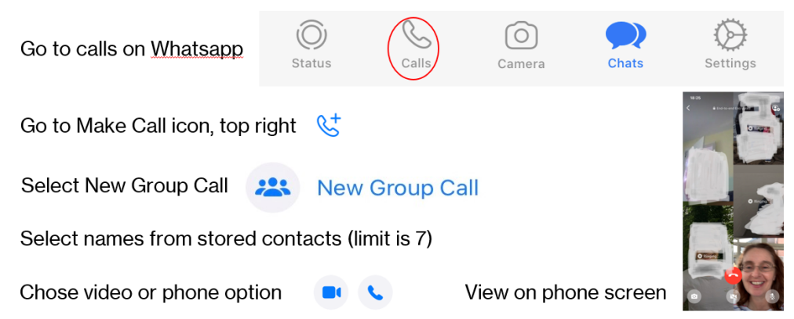

7. Still not working?
You have done your best in difficult circumstances and it is enough. Next meeting will run more smoothly. Pass back to QUB. We are all learning new ways of working. Thank you for your ongoing support.

